Ping Ultrasonic Range Finder

The SRF05 is an ultrasonic range finder. It detects the distance of the closest object in front of the sensor (from 3 cm up to 400 cm). It works by sending out a burst of ultrasound and listening for the echo when it bounces off of an object. It pings the obstacles with ultrasound. The Arduino or Genuino board sends a short pulse to trigger the detection, then listens for a pulse on the same pin using the [pulseIn()](https://www.arduino.cc/en/Reference/PulseIn) function. The duration of this second pulse is equal to the time taken by the ultrasound to travel to the object and back to the sensor. Using the speed of sound, this time can be converted to distance.

Hardware Required

* Arduino or Genuino Board
* Ultrasonic Range Finder SRF05
* hook-up wires

Circuit

The 5V pin of the SRF05 is connected to the 5V pin on the board, the GND pin is connected to the GND pin, the TRIG pin is connected to digital pin 13 on the board and the ECHO pin is connected to digital pin 12 on the board.

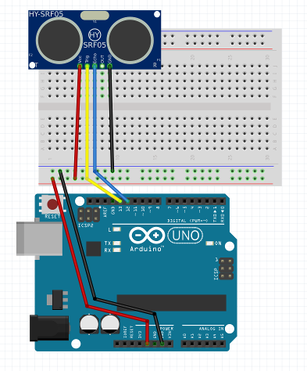

1. VCC: Chân cấp nguồn 5V
2. Trigger(T): Kích hoạt quá trình phát sóng âm. Quá trình kích hoạt khi một chu kì điện áp cao/thấp diễn ra.
3. Echo (R): Bình thường sẽ ở trạng thái 0V, được kích hoạt lên 5V ngay sau khi có tín hiệu trả về, sau đó trở về 0V
4. OUT: Không sử dụng
5. GND: Chân cấp nguồn GND

Code

Hint

To trigger the detection:

digitalWrite(TRIG_PIN, LOW);

delayMicroseconds(2);

digitalWrite(TRIG_PIN, HIGH);

delayMicroseconds(10);

digitalWrite(TRIG_PIN, LOW);

To listens for a pulse on the same pin

const unsigned long duration= pulseIn(ECHO_PIN, HIGH);

The duration of this second pulse is equal to the time taken by the ultrasound to travel to the object and back to the sensor. Using the speed of sound, this time can be converted to distance.

int distance= duration/29/2;